How to top up

Go to you log in/sign up area - https://my.beachseries.co.nz/
Please sign up

(not log in if you hace not accees this system before) this is nto the same system as the first entry so most people will need to sign up and create a password. Please note, this best done on computer or laptop using chrome as your browser.
You are only able to top up if you have entered with a series pass before. (eg before the season series started) If you have only entered 1 off events, then you can not top up, you enter as normal here https://my.beachseries.co.nz/register/?id=Beachseries2021&fbclid=IwAR3NW7IDRtabt4RWYKlu5mbraUQZpkvntEAvmTvSgqBH8GrgWqp6hce9pFg

Step up – Sign up ( if this is our frist time this season toping up)

Step 2 – Click on MY TICKETS

Step 3 – Click on Details
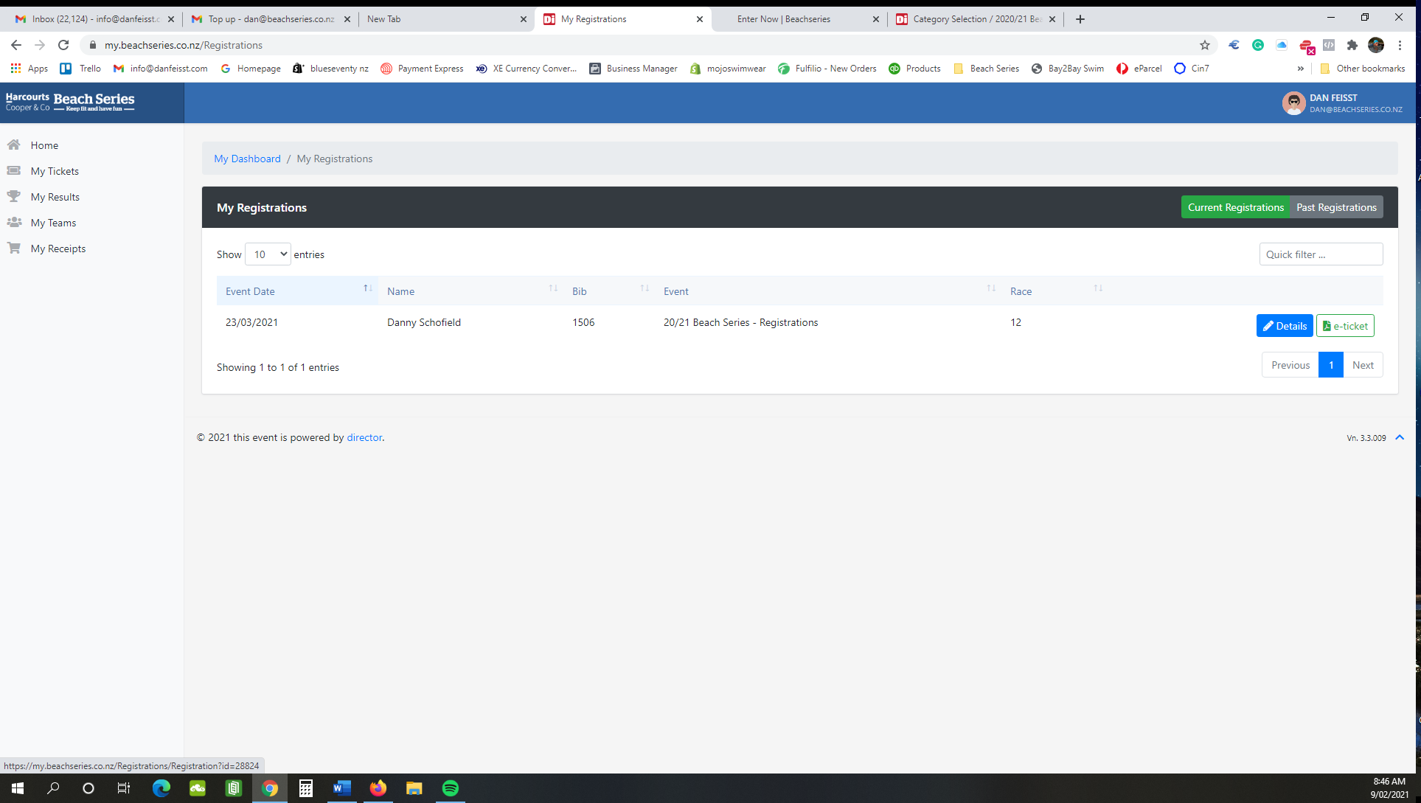

Step 4 – Click on CART ITEMS

Step 5 – Click on ADD ITEMS TO REGISTRATION

Step 6 – Now you will see the TOP UP events you can now add.

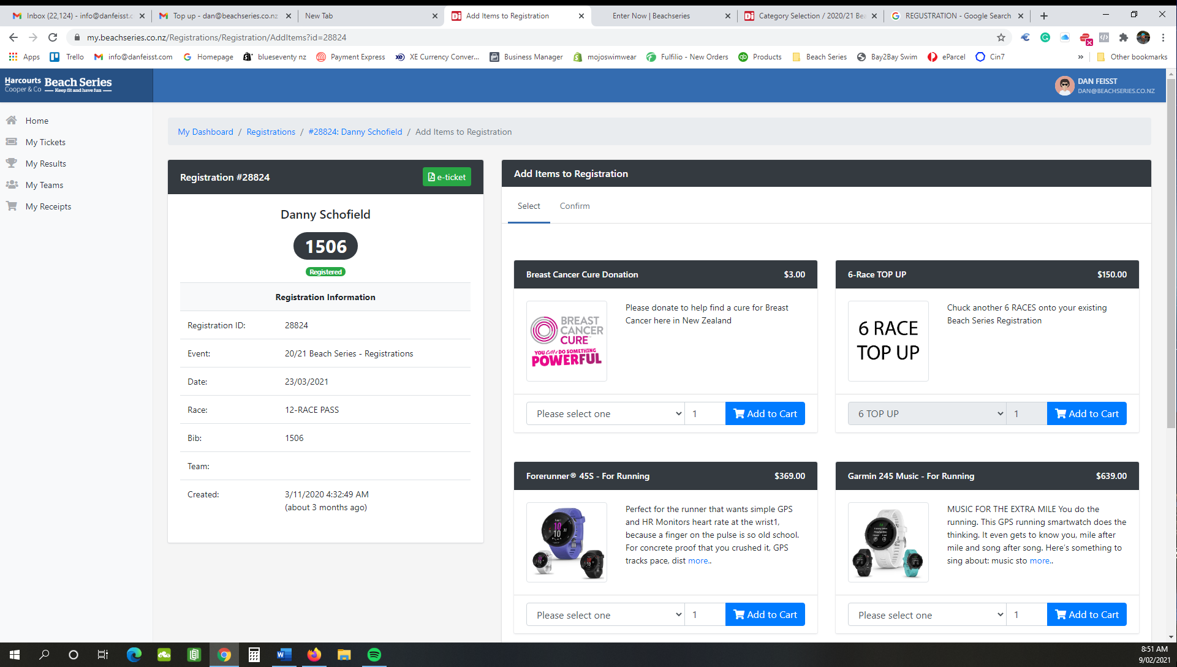

Step 7 – Now you can add your top up to the cart and pay online

